Dear Parents/Carers,
Please find attached the next overview of the phonics sounds we will be learning over the next 4 weeks. At the end of each block, I will share a new overview with you.
The rhymes for the letters and the letter formation guidance match the way we are learning in class, so your child will benefit from practising them at home too. The words highlighted in green are examples made up of the sounds your child has learnt so far – feel free to add extra words for additional practice. Practicing building these words and blending them together, as well as saying the word and segmenting to hear the individual sounds will help them, alongside beginning to read them independently.
I have also included links to some fun, interactive games that will help reinforce the sounds in a playful way. In addition, you’ll find the link to the parent portal below, where you can access helpful videos and watch the alphabet chant we sing in class each day.
Learning phonics is a vital step in helping children become confident readers and writers. Regular short practice at home, alongside what we do in school, really helps children to remember and use the sounds more quickly and successfully. Even just a few minutes each day can make a big difference.
Thank you, as always, for your continued support with your child’s learning journey.
Warm regards,
Mrs Evans
Parent Portal Code: 2l0hp6

Week | Sounds | Words to practice | Game to play | Letter formation and rhyme
5 | h- The happy horse hops | hop hug  hen big  back bat  fog fin  fan cuff  huff off | Buried Treasure  Phase 2 Set 1-4 | 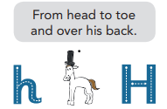
5 | b- Bat before the ball | hop hug  hen big  back bat  fog fin  fan cuff  huff off | Buried Treasure  Phase 2 Set 1-4 | 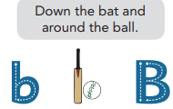
5 | f- The floppy flower falls | hop hug  hen big  back bat  fog fin  fan cuff  huff off | Buried Treasure  Phase 2 Set 1-4 | 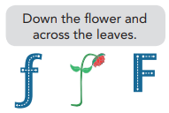
5 | ff- Huff and puff | hop hug  hen big  back bat  fog fin  fan cuff  huff off | Buried Treasure  Phase 2 Set 1-4
6 | l- The long leg leaps | get fun  luck fan  lip tell  leg hill  fuss lit  bell miss  lad tell  hiss | Picnic on Pluto  Phase 2 Set 1-4 | 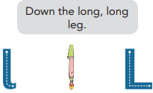
6 | ll- Bill is ill |  | Picnic on Pluto  Phase 2 Set 1-4
6 | ss- Less mess, Jess |  | Picnic on Pluto  Phase 2 Set 1-4 | 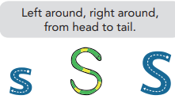
7 | j- Jane jumps for joy | fill mess  jam sell  jog vet  van web  fits jots  wet vat  well job  vets | Dragons Den  Phase 3 Sets 1-5 | 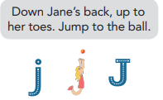
7 | v- The vulture veers over valleys |  | Dragons Den  Phase 3 Sets 1-5 | 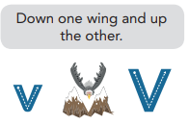
7 | w- Watch the worm wiggle |  | Dragons Den  Phase 3 Sets 1-5 | 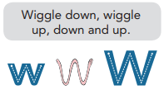
8 | x- The excited fox exercises | fill mess  jam sell  jog vet  van web  fits mix  zips yet  six yes  zaps | Buried Treasure  Phase 3 Sets 1-6 | 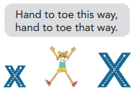
8 | y- Yank the yellow yo-yo |  | Buried Treasure  Phase 3 Sets 1-6 | 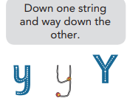
8 | z- Zip the zig-zag zip |  | Buried Treasure  Phase 3 Sets 1-6 | 

