Dear Parents/Carers,
Please find attached an overview of the phonics sounds we will be learning over the next 4 weeks. At the end of each block, I will share a new overview with you.
The rhymes for the letters and the letter formation guidance match the way we are learning in class, so your child will benefit from practising them at home too. The words highlighted in green are examples made up of the sounds your child has learnt so far – feel free to add extra words for additional practice. Practicing building these words and blending them together, as well as saying the word and segmenting to hear the individual sounds will help them, alongside beginning to read them independently.
I have also included links to some fun, interactive games that will help reinforce the sounds in a playful way. In addition, you’ll find the link to the parent portal below, where you can access helpful videos and watch the alphabet chant we sing in class each day.
Learning phonics is a vital step in helping children become confident readers and writers. Regular short practice at home, alongside what we do in school, really helps children to remember and use the sounds more quickly and successfully. Even just a few minutes each day can make a big difference.
Thank you, as always, for your continued support with your child’s learning journey.
Warm regards,
Mrs Evans
Parent Portal

Week | Sounds | Words to practice | Game to play | Letter formation and rhyme
1  15/09 | s- The snake slides and slithers | at  sat  pat  tap  sap | Buried Treasure  Phase 2 Set 1 | 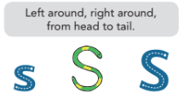
1  15/09 | a- Alphie asks for apples | at  sat  pat  tap  sap | Buried Treasure  Phase 2 Set 1 | 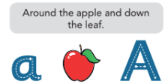
1  15/09 | t- Tap the tall tower | at  sat  pat  tap  sap | Buried Treasure  Phase 2 Set 1 | 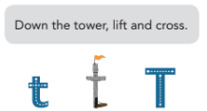
1  15/09 | p- Peek at the proud parrot | at  sat  pat  tap  sap | Buried Treasure  Phase 2 Set 1 | 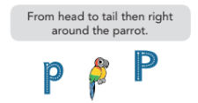
2  22/09 | i- Imagine itchy insects | it  in  sit  pit  tip  pan  pin  tin | Picnic on Pluto  Phase 2 Set 1 | 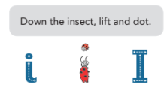
2  22/09 | n- Ned is near the net | it  in  sit  pit  tip  pan  pin  tin | Picnic on Pluto  Phase 2 Set 1 | 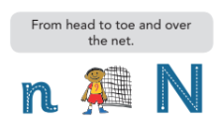
2  22/09 | m- The man marches on mountains | it  in  sit  pit  tip  pan  pin  tin | Picnic on Pluto  Phase 2 Set 1 | 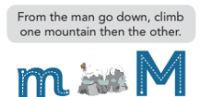
2  22/09 | d- Don’t disturb the dinosaur | it  in  sit  pit  tip  pan  pin  tin | Picnic on Pluto  Phase 2 Set 1 | 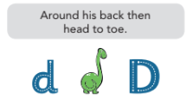
3  29/09 | g- The girl is glad | did  got  kid  pot  gap  cop  pop  dog | Dragons Den  Sets 1 & 2 | 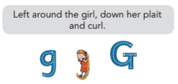
3  29/09 | o- The octopus observes olives | did  got  kid  pot  gap  cop  pop  dog | Dragons Den  Sets 1 & 2 | 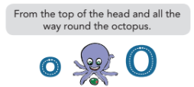
3  29/09 | c- The curly caterpillar crawls | did  got  kid  pot  gap  cop  pop  dog | Dragons Den  Sets 1 & 2 | 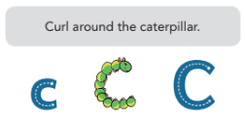
3  29/09 | k- The kangaroo keeps kicking | did  got  kid  pot  gap  cop  pop  dog | Dragons Den  Sets 1 & 2 | 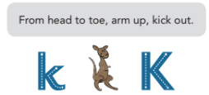
4  06/10 | ck- The chick pecks | get  cat  peg  mud  pick  run  rip  rock | Buried Treasure  Sets 1, 2 & 3
4  06/10 | e- Every elephant enters | get  cat  peg  mud  pick  run  rip  rock | Buried Treasure  Sets 1, 2 & 3 | 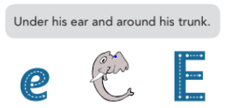
4  06/10 | u- The upside-down umbrella is unusual | get  cat  peg  mud  pick  run  rip  rock | Buried Treasure  Sets 1, 2 & 3 | 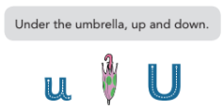
4  06/10 | r- The rapid rabbit races | get  cat  peg  mud  pick  run  rip  rock | Buried Treasure  Sets 1, 2 & 3 | 

